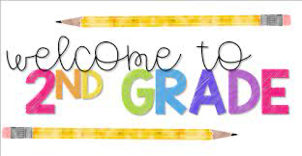

We are excited to meet all of you and have an awesome year together.

Supply List for 2nd grade

* Headphones (iPad compatible)
* Backpack
* #2 pencils
* 1 box of tissue
* Erasers 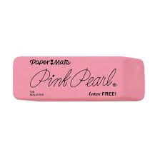
* 2 fine-tip dry erase markers
* 6 dry erase markers
* Reem of copy paper
* 2 Composition Notebooks (see image below)- No spiral

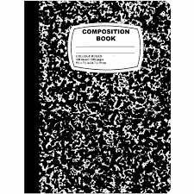

* Reusable water bottle
* $20 class fee- this is to purchase additional materials to enhance our overall learning experience.

Additional Supplies for individual classes

|  |  |  |
| --- | --- | --- |
| Mrs. Saunders | Mrs. Nightingale | Ms. Biglow |
| Colored Pencils  Box of Crayons  Scissors | Cap erasers | Cap erasers  Pencil Box |